Traffic Light Classification using VGG16 Transfer Learning

1. Introduction
Accurate traffic light recognition is important for autonomous vehicles because an incorrect decision at a red or green signal can lead to unsafe driving behaviour. This project developed a binary image classification system to distinguish between two-light traffic signals showing either Green or Red. The dataset contained 200 images organised into two folders, Green and Red, with 100 images in each class. Because the dataset was small, transfer learning was selected instead of training a deep network from scratch. A pretrained VGG16 model was used as the convolutional feature extractor, and three modelling stages were compared: a frozen VGG16 baseline with data augmentation, a regularised VGG16 model, and a conservative fine-tuned VGG16 model.
The main aim was not only to maximize accuracy on one small test split, but also to evaluate whether the model generalized reliably. VGG16 was chosen as a more suitable pretrained architecture for this coursework.

2. Dataset Preparation
The dataset was provided as a zipped directory named traffic.zip. After extraction, it contained two subdirectories: Green and Red. The images were loaded using OpenCV. OpenCV reads image channels in BGR order, while VGG16 preprocessing expects images in the usual RGB order. Therefore, every image was converted from BGR to RGB using cv2.cvtColor before resizing. All images were resized to 224 by 224 pixels because this is the standard input size for VGG16.
The labels were encoded using LabelEncoder and converted to one-hot format using to_categorical. This allowed the model to use a two-neuron softmax output layer with categorical cross-entropy loss. The dataset was split using stratification to preserve the equal number of Green and Red images in each subset. The split was 70% training, 15% validation and 15% testing, giving 140 training images, 30 validation images and 30 testing images. Stratification was important because the dataset was small; without it, one subset could contain an unbalanced number of red or green examples.
Table 1
Stratified dataset split used for training, validation and testing.
Subset | Total images | Green | Red
Training | 140 | 70 | 70
Validation | 30 | 15 | 15
Testing | 30 | 15 | 15

Data augmentation was applied inside the model so that transformations occurred only during training. The augmentation pipeline included horizontal flipping, small rotations, zooming and contrast adjustment. These transformations were useful because real traffic-light images can vary due to camera position, distance, lighting, and environmental conditions. Augmentation therefore helped the model learn more general visual patterns rather than memorising the exact training images.

3. Model Design
The baseline model used VGG16 with include_top=False, which removed the original ImageNet classification layers. The convolutional base was frozen so that its pretrained weights were not updated during training. This allowed VGG16 to act as a feature extractor. A new classification head was added consisting of GlobalAveragePooling2D, a dense layer, dropout and a final Dense(2, activation="softmax") layer. The softmax output produced probabilities for the Green and Red classes.
Three experiments were then compared. Model 1 was the frozen VGG16 baseline with data augmentation. Model 2 was an improvement using L2 regularisation and a higher dropout rate, while still using a frozen VGG16 base. Model 3 was an improvement using classification threshold tuning. This threshold method was applied to the baseline model probabilities, not compounded on top of Model 2.

4. Model 1: Frozen VGG16 with Data Augmentation

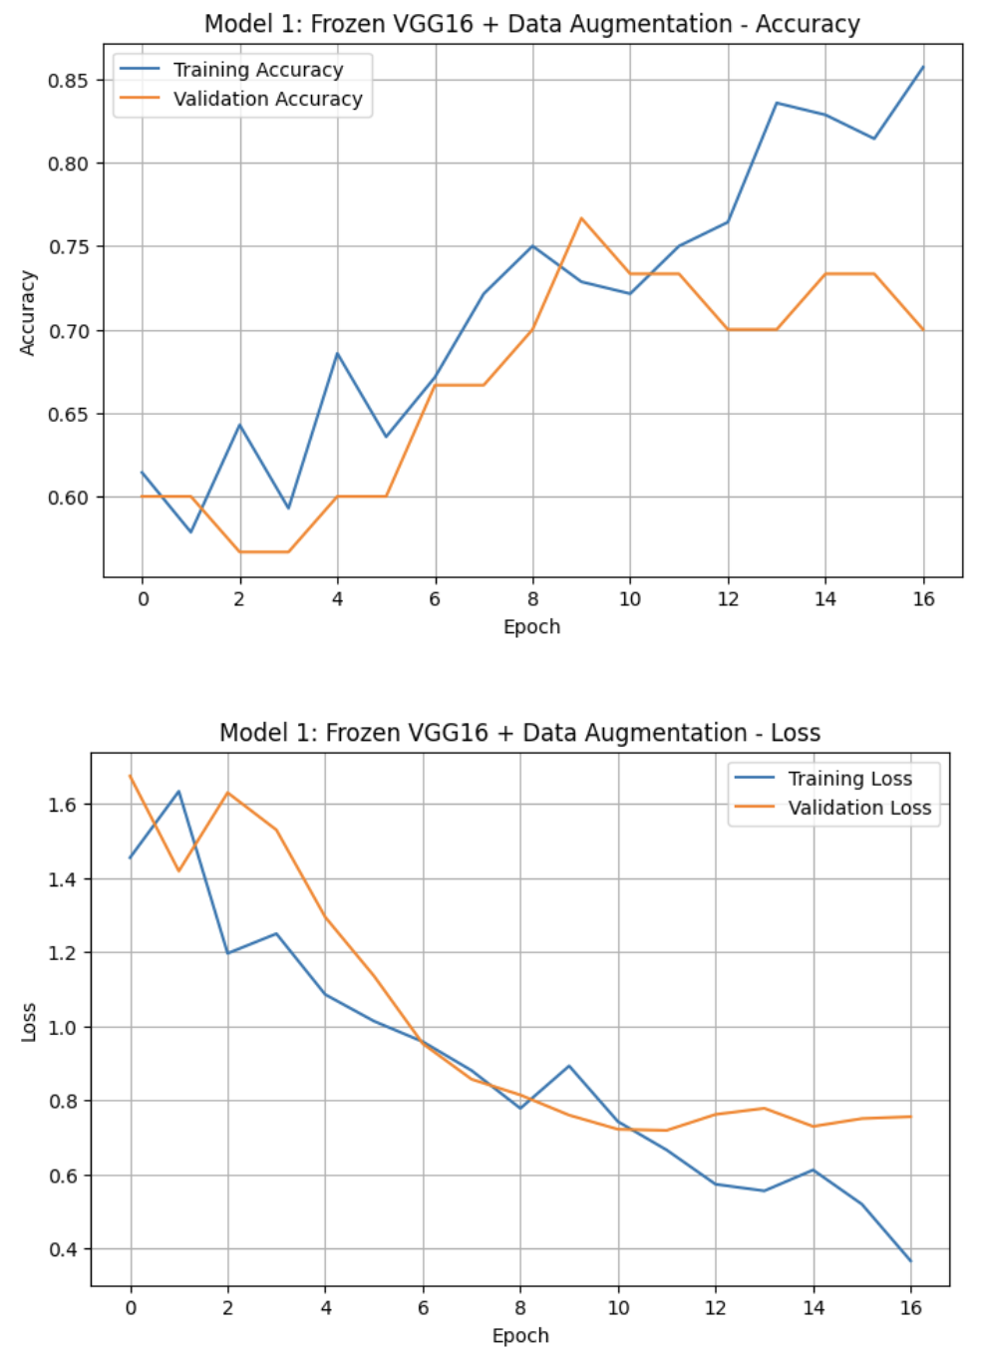
Figure 4.1: Model 1 training and validation accuracy/loss curves.
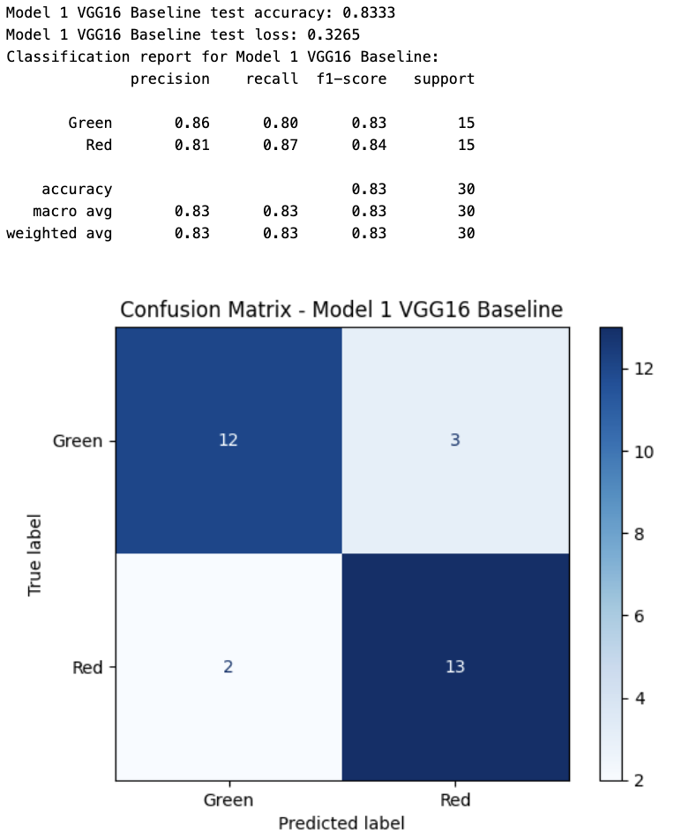
Figure 4.2: Model 1 classification report and confusion matrix.
Model 1 achieved a test accuracy of 83.33% and a test loss of 0.3265. The classification report showed a macro precision of 0.83, macro recall of 0.83 and macro F1-score of 0.83. The confusion matrix showed that 12 (80%) out of 15 Green images were correctly classified, while 3 Green images were predicted as Red. For the Red class, 13 (86.67%) out of 15 images were correctly classified, while 2 Red images were predicted as Green.
The learning curves show that the model learned steadily. Training accuracy increased from around 61% to about 86%, while validation accuracy rose from around 60% to 70-77% during training. Training loss decreased strongly from about 1.45 to below 0.4, while validation loss initially decreased and then levelled out near the later epochs. This indicates that the model learned useful features, but the gap between training and validation loss suggests overfitting towards the end.

5. Improvement Method 1: Applying L2 Regularisation

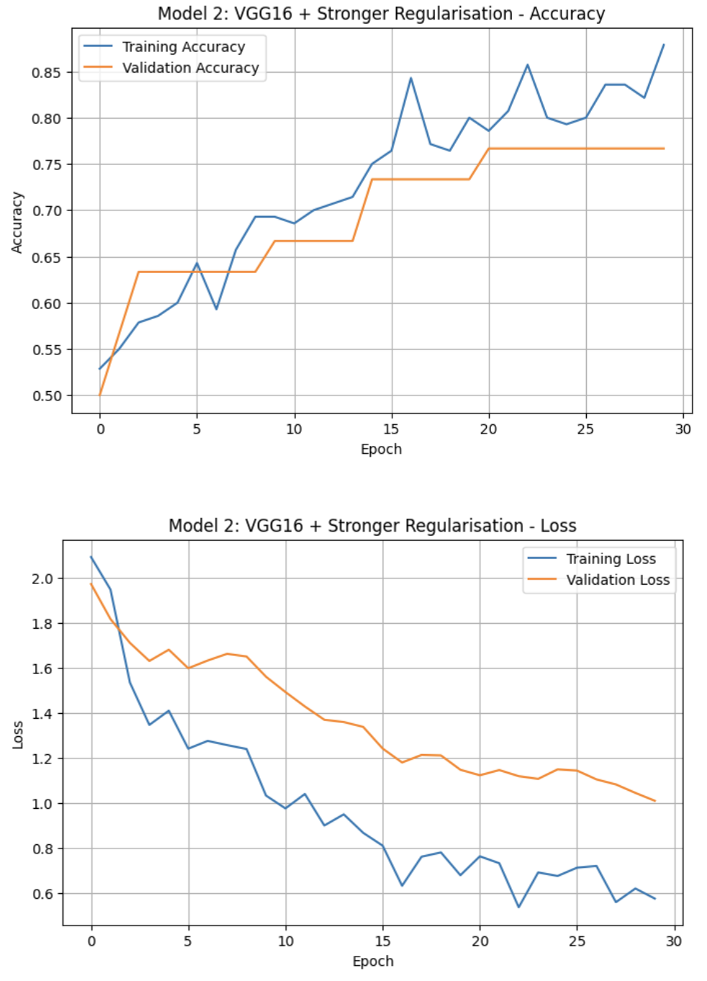
Figure 5.1: Model 2 training and validation accuracy/loss curves.
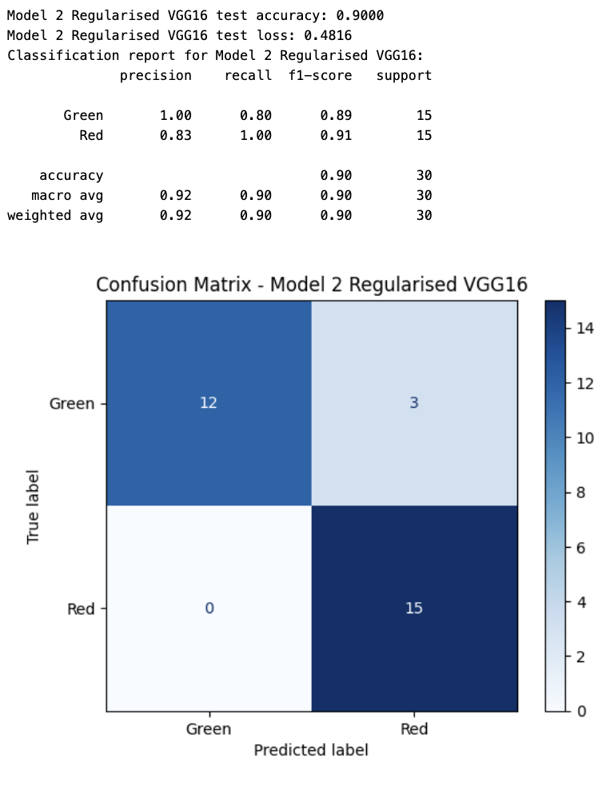
Figure 5.1: Model 2 classification report and confusion matrix.
The first improvement method modified the classifier head by adding stronger regularisation. L2 regularisation was applied to the dense layer and dropout was increased. This method was tested against the baseline model, with the VGG16 convolutional base still frozen. The aim was to reduce overfitting by discouraging overly complex weights and preventing the classifier from relying too strongly on a small number of neurons.
Model 2 improved the test accuracy from 83.33% to 90.00%. The macro F1-score also improved from 0.83 to 0.90. The confusion matrix showed that all 15 Red images were correctly classified, eliminating the Red-to-Green errors seen in Model 1. The Green class still had 3 errors, with 12 out of 15 Green images correctly classified. From a safety perspective, this was an important improvement because the model avoided the more dangerous mistake of predicting a Red traffic light as Green.
The training curves also show useful behaviour. Training accuracy rose gradually to approximately 88%, while validation accuracy reached around 77%. Training loss decreased from above 2.0 to around 0.6. Validation loss decreased more slowly and ended around 1.0, showing that the model still had some generalisation gap. However, the final test results improved clearly compared with Model 1. Therefore, stronger regularisation was considered a successful improvement method and Model 2 was eventually selected as the best final classifier.

6. Improvement Method 2: Classification Threshold Tuning
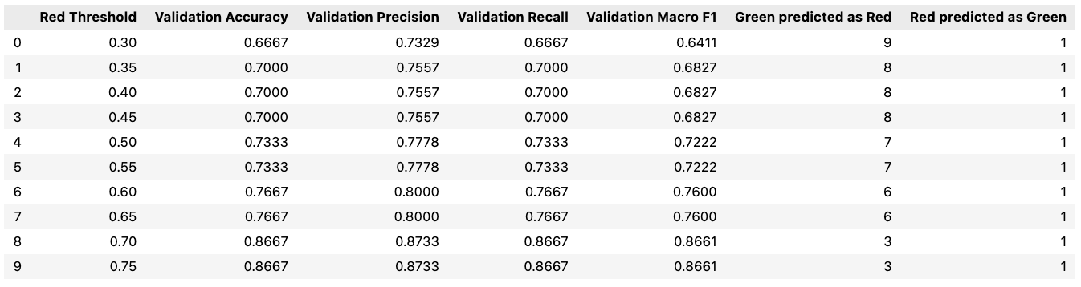
Figure 6.1: Validation results for different Red-class probability thresholds.
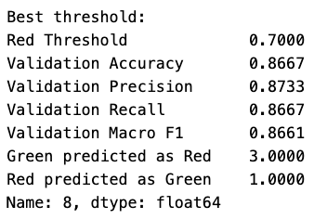
Figure 6.3: Best selected Red-class threshold from the validation set.
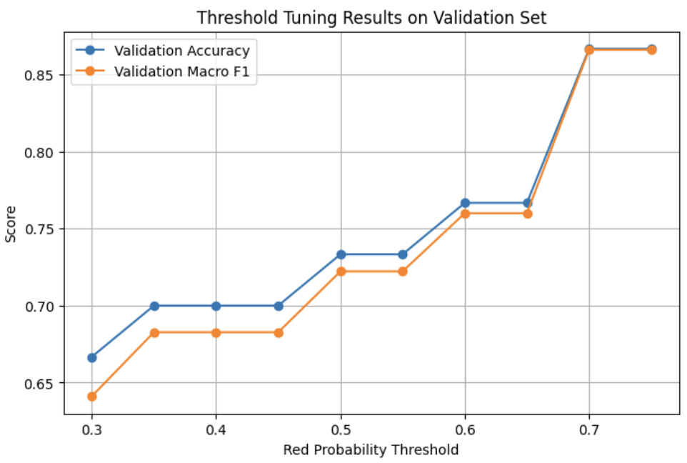
Figure 6.1: Threshold tuning validation accuracy and macro F1-score.
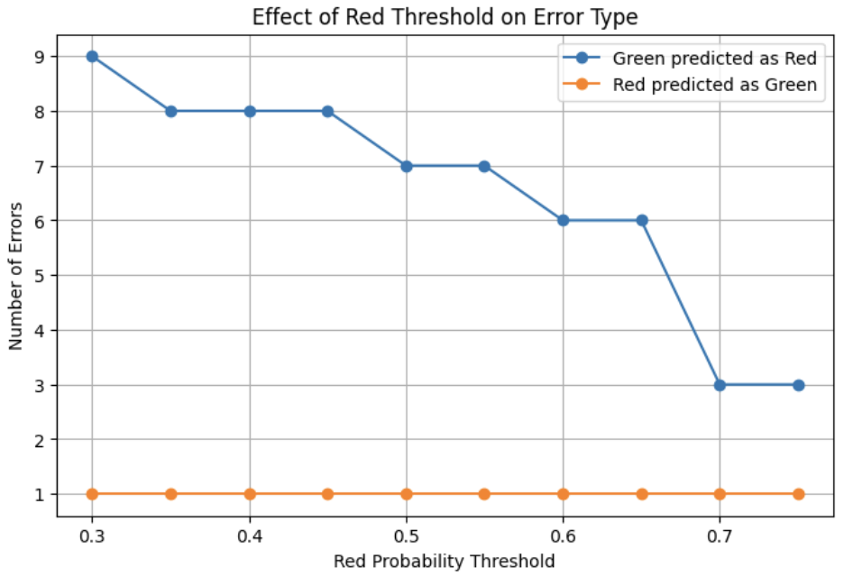
Figure 6.2: Effect of Red probability threshold on error type.
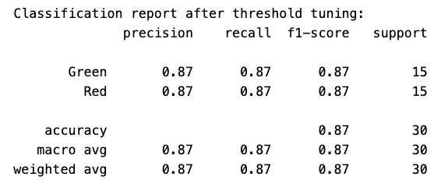
Figure 6.3: Classification report after threshold tuning.
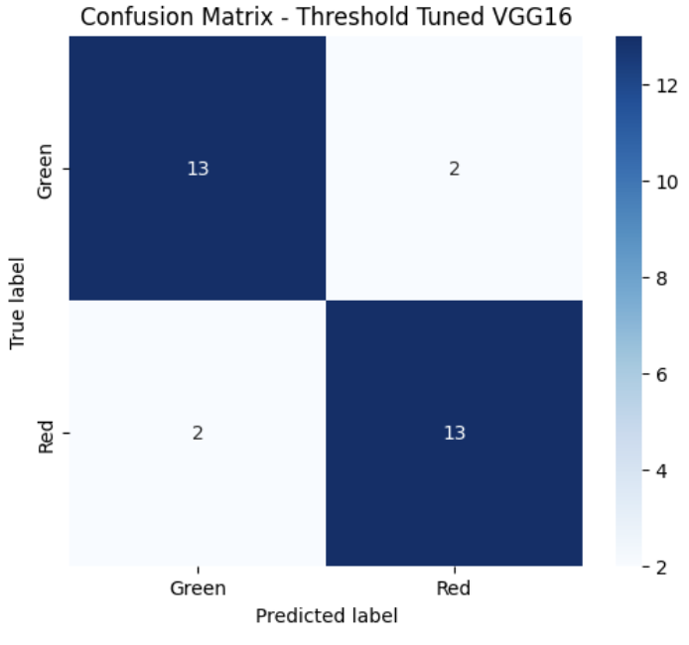
Figure 6.4: Confusion matrix after threshold tuning.
The second improvement method was classification threshold tuning. This improvement method did not train a new network. Instead, it changed the final decision rule used to convert class probabilities into labels. The baseline softmax rule predicts the class with the highest probability. Since Model 1 misclassified some Green images as Red, different Red-class probability thresholds were tested on the validation set. The aim was to reduce Green-to-Red errors by requiring a stronger Red probability before predicting Red.
The best threshold selected from the validation set was 0.70. At this value, validation accuracy and validation macro F1-score both reached 0.8667. The error-type plot showed that increasing the Red threshold reduced Green images being predicted as Red from 9 errors at threshold 0.30 to 3 errors at threshold 0.70. This provided evidence that threshold tuning directly addressed the class-specific error pattern observed in the baseline.
On the test set, threshold tuning achieved 86.67% accuracy and a macro F1-score of 0.87. This improved as compared to Model 1, which achieved 83.33%, but it did not outperform Model 2. The confusion matrix showed 13 correct Green predictions and 13 correct Red predictions, with 2 errors in each class. Therefore, threshold tuning was a useful improvement over the baseline model, but it was not the best final method. Its main value was showing that changing the decision boundary can influence the balance between Green-to-Red and Red-to-Green errors.

7. Model Comparison
Table 2
Final comparison of the baseline and independent improvement methods.
Model | Method | Test accuracy | Macro F1-score | Main finding
Model 1 | Frozen VGG16 + data augmentation | 83.33% | 0.83 | Baseline; 5 errors
Model 2 | Stronger regularisation | 90.00% | 0.90 | Best model; no Red-to-Green errors
Model 3 | Threshold tuning on baseline | 86.67% | 0.87 | Improved Model 1 but did not beat Model 2

The comparison shows that both improvement methods improved on Model 1 independently. Stronger regularisation improved accuracy from 83.33% to 90.00%, while threshold tuning improved accuracy from 83.33% to 86.67%. Model 2 was the best final classifier because it achieved the highest accuracy and eliminated Red-to-Green errors on the test set. Model 3 was still useful because it showed that the default softmax decision boundary was not necessarily optimal, but its final performance was lower than Model 2.

8. Five Unseen Test Image Predictions
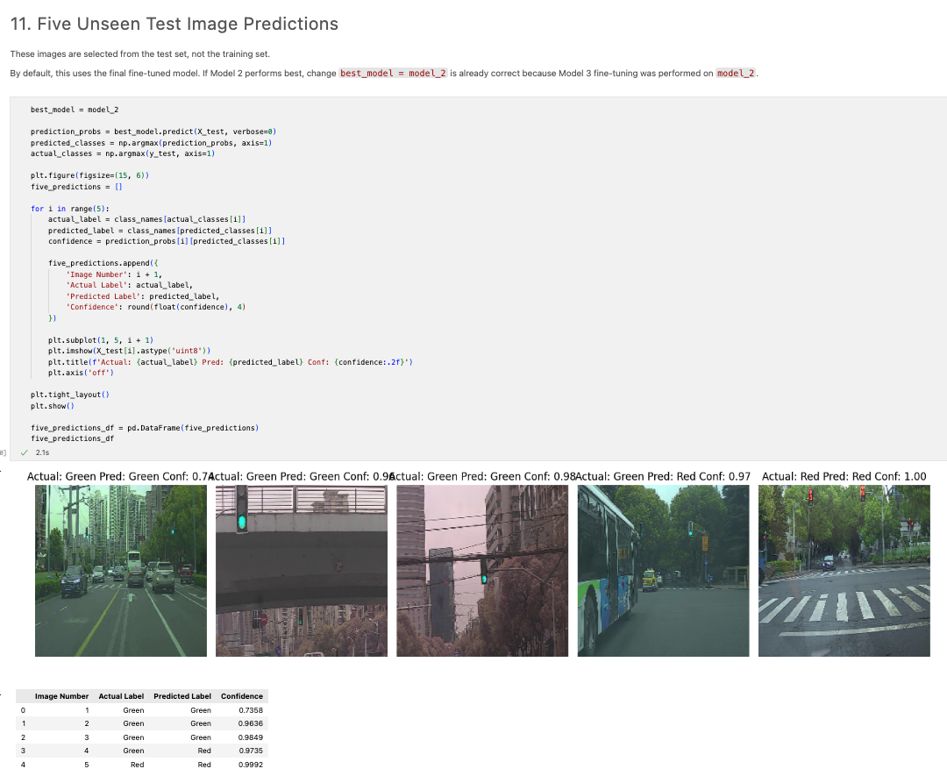
Figure 8.1: Five unseen test images selected from the test set with predicted labels.
Table 3
Five selected unseen test-image predictions using the final selected model.
Image | Actual label | Predicted label | Confidence
1 | Green | Green | 0.7358
2 | Green | Green | 0.9636
3 | Green | Green | 0.9849
4 | Green | Red | 0.9735
5 | Red | Red | 0.9992

The five sample predictions demonstrate that the final model correctly classified four out of the five displayed test images. Three Green images were correctly predicted as Green, one Green image was incorrectly predicted as Red, and one Red image was correctly predicted as Red. The incorrect Green-to-Red prediction is consistent with the overall confusion matrix, where Green images were harder for the model than Red images. In practical autonomous vehicle use, this type of error is less dangerous than predicting Red as Green, but it would still reduce driving efficiency because the vehicle may stop unnecessarily.

9. Conclusion
This project developed a binary traffic-light classifier using VGG16 transfer learning. The dataset was prepared using OpenCV loading, BGR-to-RGB conversion, resizing to 224 by 224 pixels, one-hot label encoding, stratified splitting and data augmentation. Model 1 provided a baseline accuracy of 83.33%. Two independent improvement methods were then tested. Stronger regularisation produced the best result, improving accuracy to 90.00% and removing all Red-to-Green errors. Threshold tuning also improved the baseline to 86.67%, but did not outperform the regularised model. Therefore, the final selected classifier was Model 2, the regularised VGG16 model. Further improvement would require a larger and more varied dataset, especially more difficult Green examples, and testing under different lighting, weather and camera-distance conditions.
Future work should test the model on a larger and more varied dataset containing different lighting conditions, camera angles, weather conditions and traffic-light designs before deployment in a real autonomous vehicle setting.

